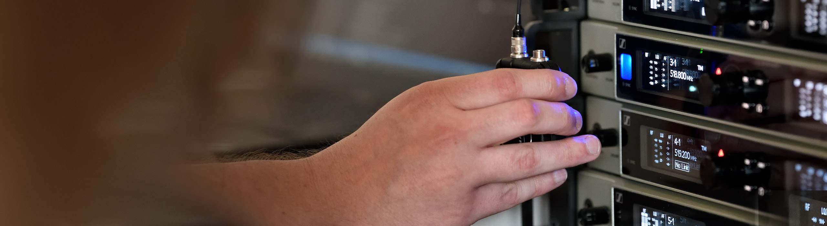

# #Dontstoptheeducation

## Join Sennheiser’s APAC Special Round Table on Live Sound and Theatrical Sound Design

***Wedemark, 23 April 2020* – The Sennheiser SoundAcademy is pleased to announce an APAC region special round table on live sound and theatre audio: On April 28 at 19:00 Singapore time (13:00 Berlin time), Sennheiser hosts Tim Moore, Faz Salleh and Zoul Mohd will welcome five leading audio professionals from the APAC region to discuss their approach to Live Sound, Theatrical Audio and Sound Design. Jeffrey Yue, Justin Tan, Justin Santos, Sunil Kumar and Reuben Ong will be available to answer your questions.**

If you haven’t participated in any of the previous SoundAcademy virtual round tables, now is the time to tune in for valuable insights from leading audio engineers and sound designers. The live discussion will last 90 minutes. Registration is now open at <https://zoom.us/webinar/register/WN_NKEV2My_TRmMrY5pyfcXDg>

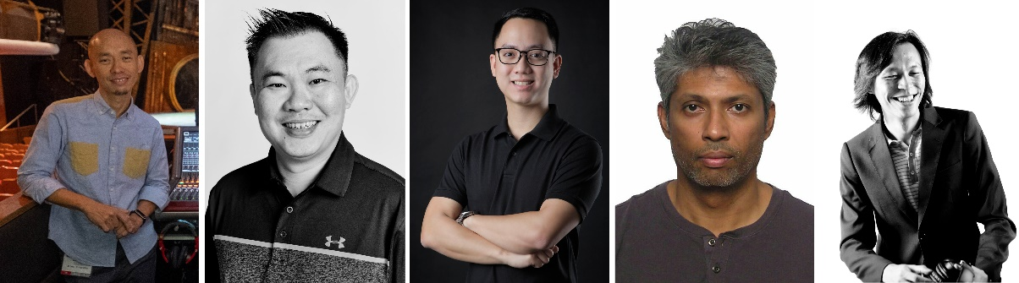

The panellists in the APAC Round Table on Live Sound, Thetarical Audio and Sound Design (from left to right): Jeffrey Yue, Justin Tan, Justin Santos, Sunil Kumar and Reuben Ong

**More about the panellists**

**Jeffrey Yue**

Jeffrey is a Theatre Sound Designer and the co-owner of Singapore-based Ctrl Fre@k Pte Ltd, a show design company which specializes in creative and system designs for performing arts, themed entertainment, arts installations, venues and festivals. Jeffrey was awarded the Glaxo-Wellcome/EDB scholarship to pursue a degree in technical theatre at the prestigious Guildhall School of Music and Drama in London. Upon graduation, he returned as Sound Coordinator for the Esplanade, Theatres on the Bay, Singapore, where he oversaw day-to-day production requirements of the multi-venue performance arts centre. With his focus on theatrical sound design and production engineering, Jeffrey has worked extensively in Singapore and other parts of the world. Recent notable work includes the Singapore Bicentennial Experience – a flagship event that marked the 200th anniversary celebration of the founding of Singapore.

**Justin Tan**

Justin is the Managing Director of J5 Productions Pte Ltd rental company in Singapore, which he founded in 2010. With a passion for audio engineering, he graduated from the School of Audio Engineering and has pursued his career in the industry ever since, focusing on professional sound design, soundscape production for houses of worship, live and M.I.CE. events. Once an audio tech practitioner and educator in his local church, he has empowered the younger generation to take up the task, getting them interested in the audio industry.

**Justin Santos**

Justin is a Live Sound Engineer and works for Forscink Inc. in the Philippines. He is also a Member of AES Philippines. Justin literally grew up in the live audio industry in the Philippines as his father is one of the pioneers of the country’s audio visual equipment rental industry. Justin studied Business Management at the Ateneo de Manila University in Manila, Philippines, followed by Show Production at Full Sail University in Orlando, Florida. He currently works for Forscink Inc. as a sound engineer and systems tech on various shows. Justin is also active in giving back to the local community through his involvement with the Audio Engineering Society Philippines Section by helping promote audio education in the country.

**Sunil Kumar**

Sunil is a Freelance Sound Engineer from Malaysia. With a wide and varied professional career in the production arts, Sunil’s love for music and audio has generated a large body of work with collaborators around the region. From recording environments and live performances, to theatre and broadcasting, he has worked and produced at almost every level of the chain. With a career spanning 25 years, Sunil has engineered more than 20 albums, produced over 30 TV productions and mixed hundreds of live performances. Sunil is also an AV Consultant to the KL Convention Centre, Technical Director for The Jazz Association of Singapore and an AV Designer for numerous event organisers in Singapore and Kuala Lumpur.

**Reuben Ong**

Reuben is the Head of Audio at The Star Performing Arts Centre in Singapore. Reuben started working in technical productions back in 2008 while still at university, being involved in university-wide events and completing his internship with a local production rental company. Upon graduating with a double degree in marketing and psychology from Singapore Management University, he started as a freelance audio technician. His work moved him through various roles in live sound and gave him insights into technical production in its entirety. In addition to audio, he has also honed his skills in theatre lighting and has designed several local theatres and dance productions. Reuben also serves as a volunteer in his local church as the Head of Productions.

**Expand your expertise with more webinars – totally free**

In addition to round tables, Sennheiser’s SoundAcademy provides a host of other popular pro audio training webinars and in-depth product discussions. Please visit <https://www.sennheiser.com/webinars> for a full, up-to-date list and to register free of charge for a SoundAcademy webinar of your choice. The free training sessions are offered at several different times to allow as many people from around the globe to tune in as possible.

[](https://www.sennheiser.com/webinars)

**For your social media channels**

## Join Sennheiser’s APAC round table on live sound and theatrical sound design and meet leading sound professionals online! #Don’tStopTheEducation

|  |  |
| --- | --- |
| Facebook post for Sennheiser's APAC round table | Leading sound professionals from the APAC region will discuss their approach to Live Sound, Theatrical Audio and Sound Design |
| Instagram post for Sennheiser's APAC round table | Instagram Story photo for Sennheiser's APAC round table |

**About Sennheiser**

Founded in 1945, Sennheiser is celebrating its 75th anniversary this year. Shaping the future of audio and creating unique sound experiences for customers – this aim unites Sennheiser employees and partners worldwide. The independent family company, which is managed in the third generation by Dr. Andreas Sennheiser and Daniel Sennheiser, is today one of the world’s leading manufacturers of headphones, loudspeakers, microphones and wireless transmission systems. In 2018, the Sennheiser Group generated turnover totaling €710.7 million. www.sennheiser.com

**Global Press Contact**

Stephanie Schmidt

Stephanie.schmidt@sennheiser.com

+49 (5130) 600 – 1275